Title in English (Times New Roman 14 pt. Bold)
2.5 cm
Taro Synchrotron and Hanako Saga^{A} (Times New Roman 12 pt.)
2.5 cm
2.5 cm
Synchrotron Light Application Center, Saga Univ.
^{A}Faculty of Engineering, Saga Univ. (Times New Roman 10.5 pt. Italic)

Please prepare the 2-page manuscript following style.

1. Heading (Times New Roman 12 pt. Bold)
The text style of ‘標準’ must be chosen and the style of ‘段落’ should be set as shown in Fig. 1.

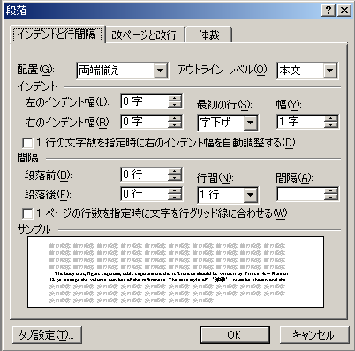

Fig. 1. Style of ‘段落’.

The body text, figure captions, table captions and the references should be written by Times New Roman 12 pt.

Acknowledgements (Bold)
作成いただいた後、高嵜宛にpdf形式にてeメールでお送りください。
メールアドレス：slctosu@ml.cc.saga-u.ac.jp

References (Bold)
[1] Authors names, Journal Title, volume , page (year).
[2] Authors names, Journal Title, volume , page (year).
[3] Authors names, Journal Title, volume , page (year).
[4] Authors names, Journal Title, volume , page (year).
2.5 cm

